#### Estimating the *Andromeda* catchability compared to the *Africana* for South African hake in an update of the Reference Case assessment

Rebecca A. Rademeyer and Doug S. Butterworth

August 2015

**Summary**

The 2013 RS1 Reference Case assessment used for OMP testing is updated to include abundance indices which have become available for the following two years. Trends are hardly altered, though for *M. paradoxus* a decline in spawning biomass over the most recent years is now evident. If instead of assuming that the catchability for the Andromeda and Africana are the same, their ratio is estimated in the assessment process, Andromeda is estimated to have a catchability 0.75 that of Africana with a 95% CI of (0.55; 1.03).

**Introduction**

Due to ongoing problems with DAFF's survey vessel (the *FRS Africana*) a commercial hake trawler (the *MV Andromeda*) was adapted for scientific deployment and has been used for the demersal surveys since 2013, i.e. the west coast summer surveys in 2013, 2014 and 2015 (AND001, AND002 and AND004) and the south coast autumn surveys in 2014 and 2015 (AND003 and AND005). Although the gear used on the *Andromeda* is the same as on the *Africana*, the *Andromeda* survey results have not yet been used in the stock **assessments** due to the need for further gear calibration to standardise the results with the historical *Africana* data. (Results of and projections for future *Andromeda* surveys were however used in OMP tests under certain assumptions concerning the *Andromeda* catchability relative to *Africana.*)

In this paper, the 2013 Reference Case assessment (RS1, Rademeyer and Butterworth, 2014) is updated to include the *Andromeda* survey data (as well as updated catch and CPUE series) and estimate a ratio for the *Andromeda*/*Africana* catchability coefficients (**). The update has been carried out as a two-steps process, first taking data to 2014 into account, then to 2015.

**Data and Methods**

The updated data (compared to those used in RS1, Rademeyer and Butterworth, 2014) are given in Appendix A.

The Andromeda survey biomass estimates are used as input to the model assuming that the *Andromeda* catchability coefficient  is proportional to that of the *Africana*:

 (1)

 is either fixed or estimated in the model fitting procedure. A singleis estimated (across species, coasts and seasons).

The survey selectivities are taken to be the same for the *Africana* and the *Andromeda*.

**Results and Discussion**

Five runs are compared:

1. "RS1" (Rademeyer and Butterworth, 2014) with data to 2013 and not using the 2013 *Andromeda* biomass estimates.
2. "ratio=1 - data to 2014": As RS1 but with data extended to 2014 (new GLM-standardised CPUE (to 2013), surveys by *Andromeda* to 2014 and catches (with 2014 catches taken as the TAC for that year split by species and fleet using the 2013 proportions), with .
3. "ratio=est - data to 2014": As "ratio=1 - data to 2014" but with the estimated in the model fitting.
4. "ratio=1 -data to 2015": As "ratio=1 - data to 2014" but with data extended to 2015 (with actual catches made for 2014 and the 2015 TAC assumed taken and split by species and fleet using the 2014 proportions) .
5. "ratio=est - data to 2015": As "ratio=1 - data to 2015" but with the estimated in the model fitting.

Results are given in Table 1. The  ratio is estimated to be 0.68 in the "ratio=est - data to 2014" case, with a 95% probability interval (0.44; 1.02) as estimated using a likelihood profile – this wide interval is a consequence of the *Andromeda* having carried out only three surveys. With data included to 2015,  is estimated to be 0.75 with a narrower 95% probability interval (0.55; 1.03).

The data update and estimating ** have rather little effect on the overall estimated trends in abundance, though there is a downward indicated for *M. paradoxus* for the most recent years (see Figure 1).

**Reference**

Rademeyer RA and Butterworth DS. 2014. Specifications of the South African Hake 2014 Reference Case Assessment. MARAM/IWS/DEC14/Hake/P2.

Table 1: Results for RS1 and the update assessments with ** =1 and ** estimated.

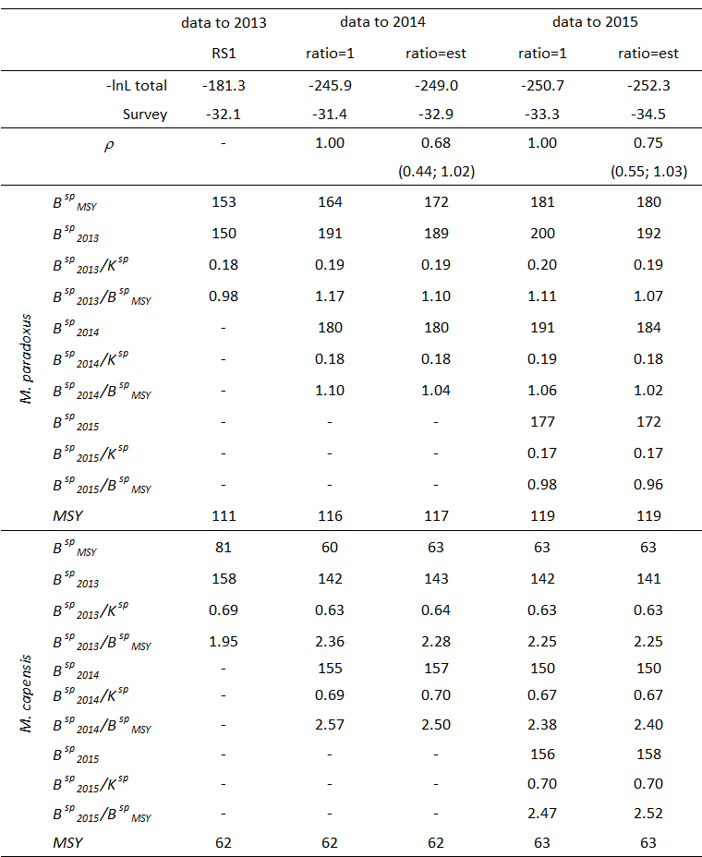

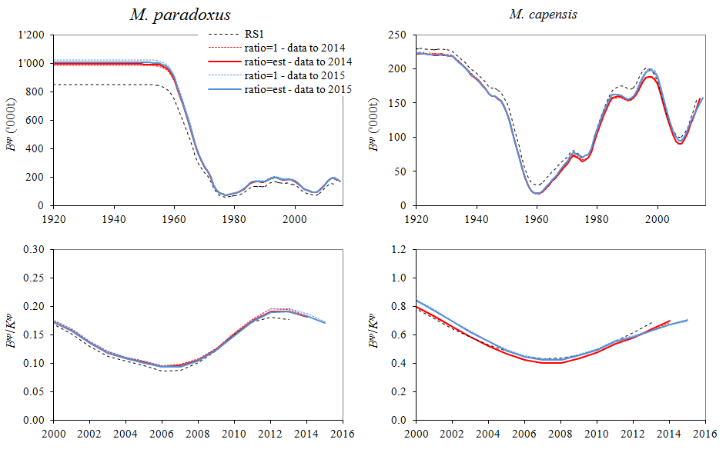

Figure 1: Spawning biomass trajectories (in absolute terms, top row, and relative to pre-exploitation level, bottom row) for the five cases for *M. paradoxus* (LHS) and *M. capensis* (RHS).

#### Appendix A: Updated data

#### Table App.A.1: Species-disaggregated catches (in thousand tons) by fleet of South African hake from the south and west coasts for the period 1978-present. The recent offshore trawl catches are from Glazer (pers. comm.), the recent inshore and handline catches are from Rob Cooper (pers. comm.) and the new longline catches from Sobahle Somhlaba (pers. comm.). For 2015, the catches are taken as the 2014 TAC with the same proportion by species and fleet as in 2013. Shaded cells are either new or updated data compared to those used for RS1.

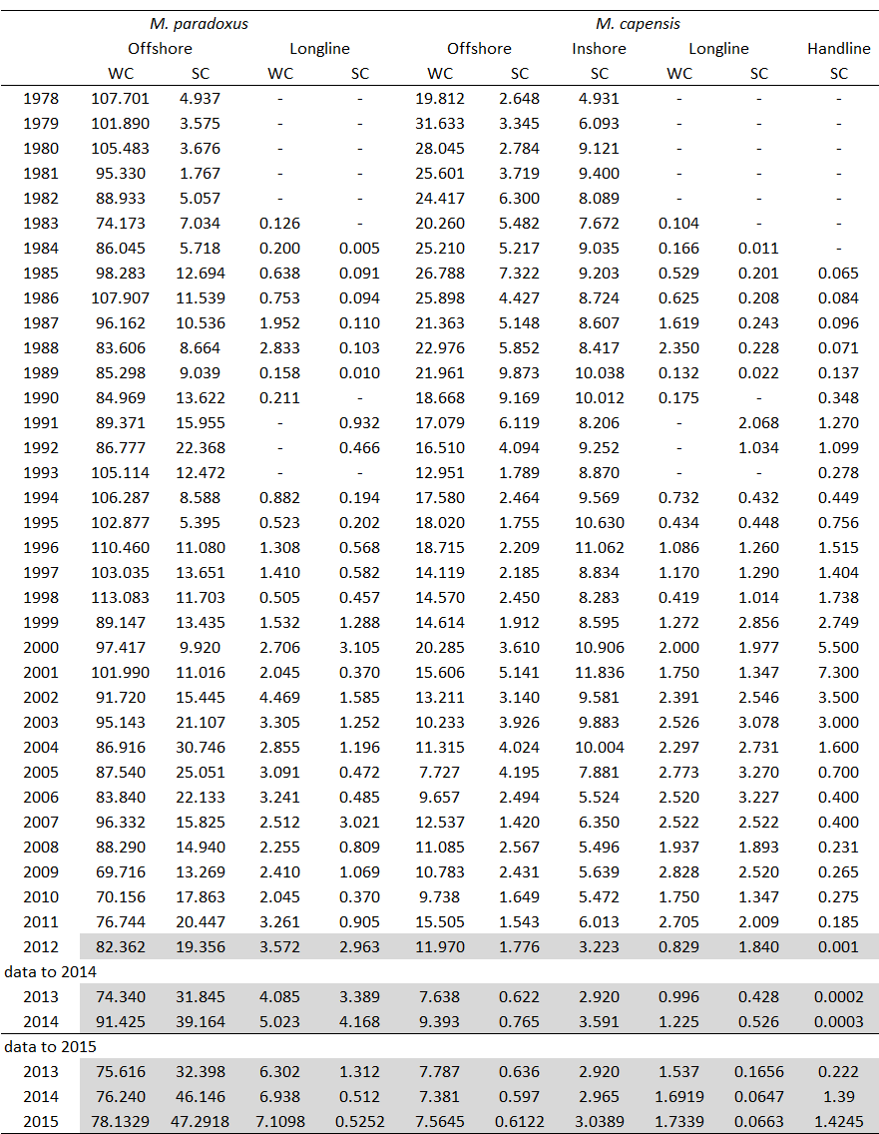

#### Table App.A.2: GLM standardized CPUE data for *M. paradoxus* and *M. capensis* (Glazer, pers. comm.). Shaded cells are either new or updated data.

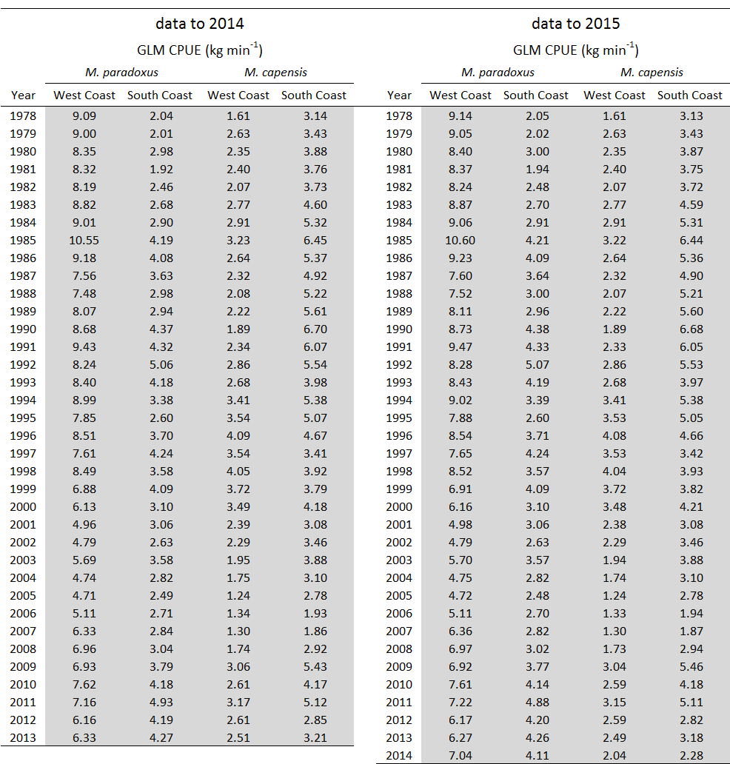

**Table App.A.3**: Survey abundance estimates and associated standard errors in thousand tons for *M. paradoxus* for the depth range 0-500m for the South Coast and for the West Coast (Fairweather, pers. comm.). Values in bold are for the surveys conducted by the *Africana* with the new gear. Shaded cells are for the surveys conducted by the *Andromeda*.

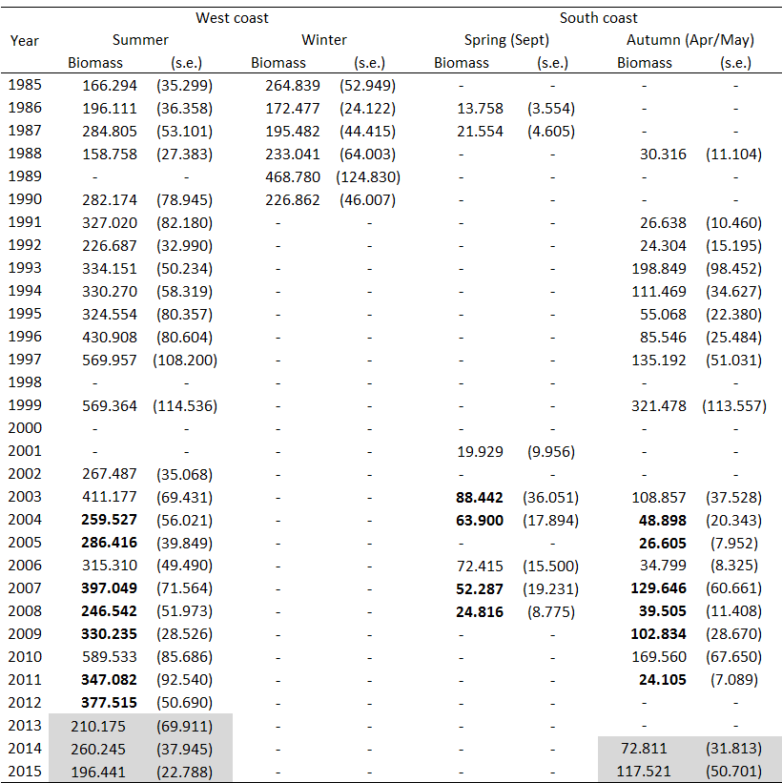

**Table App.A.4**: Survey abundance estimates and associated standard errors in thousand tons for *M. capensis* for the depth range 0-500m for the South Coast and for the West Coast (Fairweather, pers. commn). Values in bold are for the surveys conducted by the *Africana* with the new gear. Shaded cells are for the surveys conducted by the *Andromeda*.

